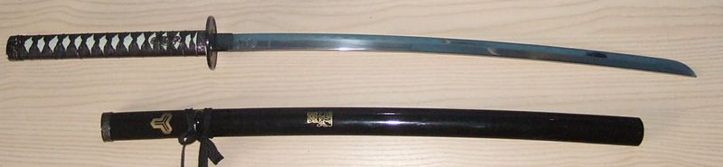

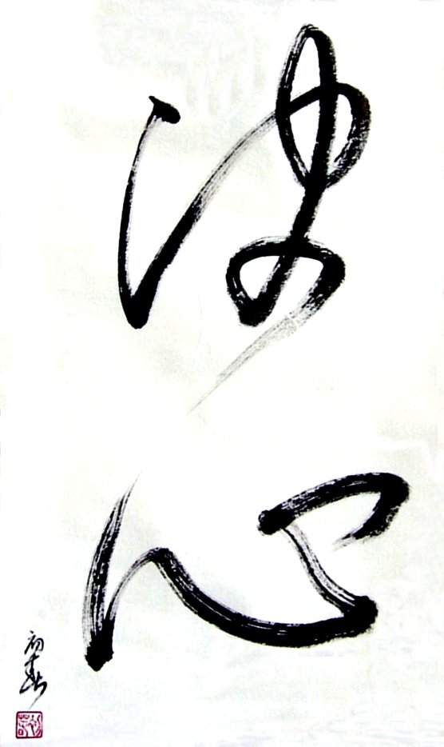

JODO & IAIDO SEMINAR

JODO : Seitei Jo and Shindo Muso Ryu
IAIDO : Muso Shinden Ryu

Jodo 28th February 2014 – Iaido 1st to 2nd March 2014

9h30 (Sunday 9h00)-12h00 / 13h30-17h30 (Sunday 16h00)

with
René Van Amersfoort Sensei, 7th Dan Renshi Iaido - Jodo

Hall Omnisport Philippe Hemet
1, Rue Pierre de Coubertin
95300 PONTOISE (North-West suburb of Paris)

REGISTRATION FORM

Send to Ms NEVROUZE Dominique - 103, rue Orfila -B4 - 75020 PARIS - France, or by E-mail

First name …………………………………..Last name ……………...…………………….
Address ………………………………………………………............................................
Zip Code ……………….…...City ……………………………........................................
Country ………………………………………………….
Phone / Fax ……………………………………………………………………...
E-mail ………………………………………………………………………….
Dojo …………………………………………………
Grade : Kyu / Dan : Jodo……………….Iaido……………………..

Seminar fees :
Jodo : Friday 35 € …….€
Iaido : 2 days : Saturday & Sunday 65 € …….€
1day, precise it : Saturday / Sunday 35 € …….€
Jodo & Iaido : All seminar 85 € …….€

Total Amount ……………………………………………………………… …….€
Payment by cash at your arrival

Accommodations :
Hôtel Campanile Cergy-Pontoise - 8, rue Pierre de Coubertin - 95300 Pontoise
Tel: + 33 1 30 38 55 44
Website: www.campanile-cergy-pontoise.fr
Don’t forget to put a cross in the case “sportif licencié” to have discount price during the weekend.

Lunch
Bring something to eat, or there is a possibility to eat at the restaurant of the hotel Campanile.
Sayonara party on Saturday evening.

Other information:
Phone / Fax : + 33 1 40 31 56 97 - Mobile : (Dom.)+ 33 6 72 91 68 64 / (Ph.) + 33 6 73 47 64 03
E Mail : dom.fil@orange.fr
Site : www.keshin.fr

