Iaido Friendship Seminar
August 22nd – 24th 2014
Newcastle upon Tyne, UK

Ojika and Budokan Dojos invite you to the North East of England to attend the 2014 European Friendship Seminar and Taikai. Entry is open to all ZNKR koryu styles and will be lead by:
Morita Tadehiko, Hachidan Kyoshi - ZNKR
Oshita Masakazu, Hachidan Kyoshi - ZNKR
supported by
Fay Goodman, Nanadan Renshi - BKA
Peter West, Nanadan Renshi - BKA
Anna Stone, Rokudan Renshi - BKA
John Honisz-Greens, Rokudan Renshi - ZNKR
Andy Watson, Rokudan Renshi - BKA
Detlef Uedelhoven, Rokudan - EKF
Henry Schubert, Rokudan - EKF
This seminar will be held between 22nd – 24th August 2014 at:
Sport Kenton
Kenton School
Drayton Road
Kenton
Newcastle upon Tyne
NE3 3RU

Due to the generosity of the BKA Iaidobu, the price for this seminar will be £60. This will include lunch on Saturday and Sunday (vegetarian and other dietary options will be available).
Applications and cheque to be sent to:
Mr D M Evans
10 Daglish Close
New Romney
Kent
TN28 8XF

Cheques payable to: Mr D M Evans. To pay by bank transfer contact Dougie for details . Non UK applicants register by email to: bigdougevans@gmail.com, a fee of €75 will be payable upon arrival at the event.
Event Timetable
Friday 22nd August
5 P.M – 8 PM Event opens
Training

Saturday 23rd August

09:30 - 12:30 Training
12:30 - 13:30 Lunch
13:30 - 16:30 Training

Sunday 24th August

09:30 - 12:30 Training
12:30 - 13:30 Lunch
13:30 - 16:30 Koryu Taikai
16:30 Seminar close

In the spirit of a Friendship seminar, the Taikai will be an opportunity to compete with new and old friends. This will be achieved by holding a team Shiai event. Teams will consist of three people, picked randomly from a hat with an even spread of grades in each team.

Directions to Dojo

The dojo is 3 miles from Newcastle International airport, and can be reached by following signs for Newcastle from the airport. Heading down the A696 roundabout over the A1, take the third exit onto the A167, at the next roundabout turn left onto Kenton Lane. The second left hand turn will take you into the school car park.

These directions are the same if travelling from either direction on the A1, Exit for city centre A167 then follow above directions.
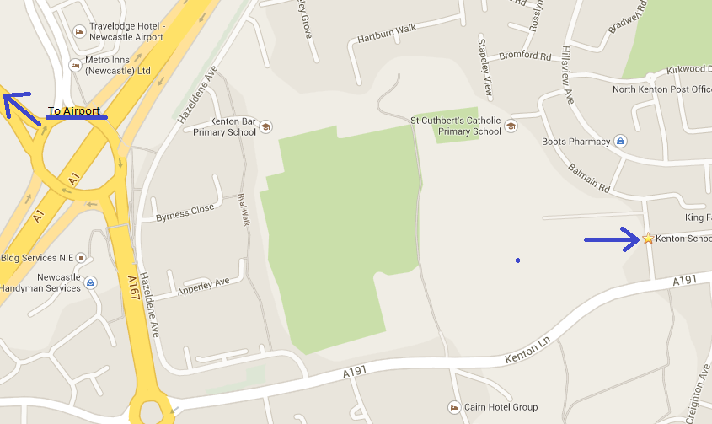

If you are arriving at the event by train to Newcastle central station there are a number of public transport links that will get you to the venue.

http://www.nexus.org.uk/

This is a very useful website which has a journey planner that will give you all the information needed to find the dojo from any part of the North East.

Some local taxi numbers that may be useful are:

Blueline Taxis - 0191 262 6666
Budget Taxis – 0191 298 5050

ACCOMMODATION

There are a large number of hotels in the Newcastle area, some of the hotels located near to the dojo are:

Novotel  Ponteland Road  NE3 3HZ  0843 8163040 | Premier Inn (airport)  NE20 9DB  0870 1977190
Travel Lodge  Kenton Bank  NE3 3TY  0871 5591830 | Brittania Hotel (Airport)  NE13 8DJ  0845 8641347
Premier Inn
Callerton Lane Ends
NE13 8DF
0871 5278798

There are plenty of other hotels and B&Bs in the Jesmond, Gosforth and Kingston park areas of Newcastle upon Tyne, and also in the city centre (about 3 miles from the venue). We advise against booking accommodation in the Fenham or Scotswood areas.

There will be an evening meal/Sayonara party on the Saturday evening, details to be announced but cost will be around £20.

Please direct any enquiries regarding the seminar, accommodation or dietary requirements to

info@ojika.org.uk

Contact numbers for organisers are

Martin Chambers: 0773 6943052 Kevin McNeill: 07528 441819
2014 European Friendship Seminar
Application Form

Name

Age

Dojo

Nationality

Grade

Style

Telephone

Email

Emergency contact details

Attending Sayonara party Y/N

Special dietary requirements (e.g vegetarian, coeliac)

